1. Importing Libraries

Code:

library(readxl)

library(tidyverse)

library(tidytext)

library(ggplot2)

* **library(readxl):** Loads the readxl package to read Excel files into R. It provides the read_excel() function to read .xlsx files.
* **library(tidyverse):** Loads the tidyverse, which is a collection of R packages designed for data manipulation, analysis, and visualization (such as dplyr, ggplot2, and others).
* **library(tidytext):** Loads the tidytext package, which is specifically designed for text mining in a tidy format. It helps in text tokenization, removing stopwords, and performing sentiment analysis.
* **library(ggplot2):** Loads the ggplot2 package, a part of tidyverse used for data visualization. It allows you to create complex plots easily using the grammar of graphics.

1. Reading Data from an Excel File

Code:

data_frame <- read_excel("D:/AIUB/Thesis/GIT/Dataset/Processed Data.xlsx", sheet = "Dhaka Regency")

View(data_frame)

* **data_frame <- read_excel(...):** This reads the Excel file located at "D:/AIUB/Thesis/GIT/Dataset/Processed Data.xlsx" and selects the sheet named "Dhaka Regency". The data is stored in the variable data_frame.
* **View(data_frame):** This opens a spreadsheet-like viewer window in RStudio to show the contents of the data_frame. This is useful for checking what the dataset looks like before further processing.

1. Tokenization (Breaking Text into Words)

Code:

tidy_data <- data_frame %>%

unnest_tokens(word, Text)

View(tidy_data)

* **unnest_tokens(word, Text):** This function from the tidytext package tokenizes (breaks) the text into individual words. Here:
* **word:** The name of the new column that will store the individual words.
* **Text:** The column in the data_frame that contains the text you want to tokenize.
* The result is a new data frame tidy_data, where each row corresponds to a single word from the original text data. The unnest_tokens() function helps convert text data into a tidy format, with each word as a separate row.
* **View(tidy_data):** Again, this opens a spreadsheet-like viewer window in RStudio to check the tokenized data.

1. Getting a Sentiment Lexicon

Code:

bing_lexicon <- get_sentiments("bing")

* **get_sentiments("bing"):** This function retrieves the Bing Liu sentiment lexicon. The Bing lexicon classifies words into two categories: positive or negative sentiment. It is used for sentiment analysis and contains words commonly associated with positive or negative emotions.

1. Performing Sentiment Analysis

Code:

sentiment_scores <- tidy_data %>%

inner_join(bing_lexicon, by = "word")

* **inner_join(bing_lexicon, by = "word"):** This performs an inner join between the tokenized words (tidy_data) and the Bing sentiment lexicon (bing_lexicon) based on the column word. An inner join keeps only the words that are present in both the tokenized dataset and the Bing lexicon.
* This step maps each word in the tidy_data to its corresponding sentiment (positive or negative) from the Bing lexicon and stores the result in sentiment_scores.

1. Summarizing the Sentiment Data

Code:

sentiment_summary_bing <- sentiment_scores %>%

group_by(sentiment) %>%

summarize(total_count = n())

* **group_by(sentiment):** This groups the data by the sentiment column (which contains either "positive" or "negative").
* **summarize(total_count = n()):** This creates a summary that calculates the total number of occurrences for each sentiment by counting the number of words associated with either "positive" or "negative" sentiment. The result is stored in sentiment_summary_bing, which contains the total number of positive and negative words.

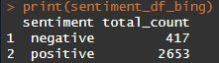

1. Converting the Summary to a Data Frame

Code:

sentiment_df_bing <- as.data.frame(sentiment_summary_bing)

print(sentiment_df_bing)

* **as.data.frame(sentiment_summary_bing):** Converts the summary of sentiments into a standard R data frame format and stores it in sentiment_df_bing.
* **print(sentiment_df_bing):** This prints the sentiment_df_bing to the console to see the summarized results, which will display the count of positive and negative words.

1. Visualizing the Sentiment Analysis Results

Code:

ggplot(sentiment_summary_bing, aes(x = sentiment, y = total_count, fill = sentiment)) +

geom_bar(stat = "identity") +

labs(title = "Sentiment Analysis", x = "Sentiment", y = "Total Count") +

theme_minimal()

* **ggplot(sentiment_summary_bing, aes(x = sentiment, y = total_count, fill = sentiment)):** This initializes a ggplot object to create a bar chart. The arguments in aes() specify:
* **x = sentiment:** The sentiment (positive or negative) will be on the x-axis.
* **y = total_count:** The total count of positive and negative words will be on the y-axis.
* **fill = sentiment:** Each bar in the bar chart will be filled with a color representing the sentiment (positive or negative).
* **geom_bar(stat = "identity"):** Adds the bars to the bar chart, where the height of each bar is determined by the actual values (not counts, which is what stat = "identity" does).
* **labs(...):** Adds labels to the plot:
* **title = "Sentiment Analysis":** The title of the plot.
* **x = "Sentiment":** The x-axis label.
* **y = "Total Count":** The y-axis label.
* **theme_minimal():** Applies a clean, minimal theme to the plot.

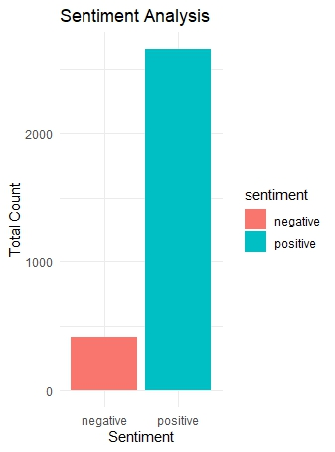

* The result is a bar plot that visually displays the number of positive and negative words in the dataset, giving insight into the overall sentiment of the text.

Summary:

1. **Data Loading:** Reads the Excel file containing hotel reviews.
2. **Tokenization:** Splits the text into individual words.
3. **Sentiment Analysis:** Uses the Bing sentiment lexicon to classify each word as positive or negative.
4. **Summary:** Groups the sentiment results to count the total number of positive and negative words.
5. **Visualization:** Creates a bar plot to visualize the sentiment analysis results.